Save in notepad++

excel => menu dropdown => data => import external data => import data. Click OK.

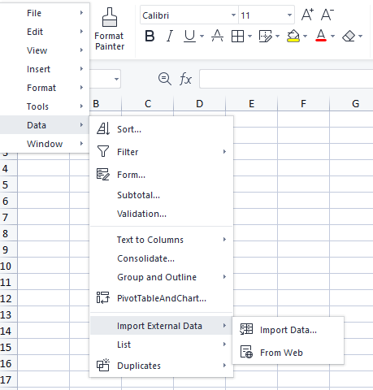

Select Data Source

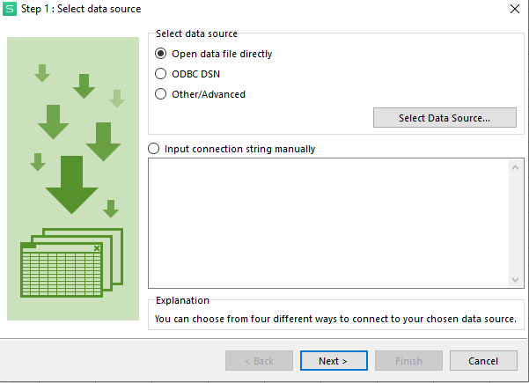

Open data file directly => other encoding => delimited => check box enable space

